Supplementary Material
Supplementary Table 1. Data gathering sources.
Source/Reference
GBIF | https://www.gbif.org/ (September 24th 2020)
iNaturalist | https://www.inaturalist.org/observations (September 24th 2020)
Silene-Flore | http://flore.silene.eu/index.php?cont=accueil (April 22nd 2021)
Tela Botanica | https://www.tela-botanica.org/
Narbona et al. 2010 (Narbona et al., 2010)
Quintela-Sabarís et al. 2011 (Quintela-Sabarís et al., 2011)
Henaoui 2013 (Henaoui, 2013)
Aparicio et al. 2017 (Aparicio et al., 2017)
Bechlaghem et al. 2019 (Bechlaghem et al., 2019)
Ferreira et al. 2021 (Ferreira et al., 2021)

Supplementary Table 2. Original set of the 19 bioclimatic variables that were selected for modeling. The selected variables are in bold.
Variable | Code | Unit
Annual mean temperature | BIO1 | °C * 10
Mean diurnal range (mean of monthly (max temp - min temp)) | BIO2 | °C * 10
Isothermality (BIO2/BIO7) (* 100) | BIO3 | %
Temperature seasonality (standard deviation *100) | BIO4 | -
Max. temperature of warmest month | BIO5 | °C * 10
Min. Temperature of Coldest Month | BIO6 | °C * 10
Temperature annual range (BIO5-BIO6) | BIO7 | °C * 10
Mean temperature of wettest quarter | BIO8 | °C * 10
Mean temperature of driest quarter | BIO9 | °C * 10
Mean temperature of warmest quarter | BIO10 | °C * 10
Mean temperature of coldest quarter | BIO11 | °C * 10
Annual precipitation | BIO12 | mm
Precipitation of wettest month | BIO13 | mm
Precipitation of driest month | BIO14 | mm
Precipitation seasonality (coefficient of variation) | BIO15 | %
Precipitation of wettest quarter | BIO16 | mm
Precipitation of driest quarter | BIO17 | mm
Precipitation of warmest quarter | BIO18 | mm
Precipitation of coldest quarter | BIO19 | mm

Supplementary Table 3. Summary of known fossil occurrences of Cistus ladanifer L. Pleistocene to present ranked by the age of the oldest record. The pollen data search was made in the Neotoma Paleoecology Database by taxon ('Cistus ladanifer'=C. ladanifer or 'Cistus ladanifer Type'=C. ladanifer Type). Age oldest = is the age of the oldest pollen record in the site. According to the pollen record oldest age the following labeling was used: Late Pleistocene (from 143.0-11.7 ka), Early-Middle Holocene (11.7-4.2 ka), and Late Holocene-Present (4.2-0 ka). Thousand years BP = ka. The remaining records were collected from the literature.
ID | Taxon | Country | Site name | Latitude | Longitude | Age oldest | Period | Reference
1* | C. ladanifer | Spain | Bajondillo | 36.6197 | -4.4964 | 142,228 | Late Pleistocene | (Cortés-Sánchez et al., 2008)
2* | C. ladanifer | Spain | Padul-Granada | 37.0000 | -3.6700 | 90,000 | Late Pleistocene | (Pons and Reille, 1988)
3* | C. ladanifer Type | Portugal | Beliche-Guadiana | 37.2667 | -7.4500 | 13,092 | Late Pleistocene | (Fletcher et al., 2007)
4* | C. ladanifer Type | Spain | PRD-4 | 42.5333 | -8.5167 | 12,768 | Late Pleistocene | (López-Merino et al., 2012)
5* | C. ladanifer | Spain | Canaleja | 40.9000 | -2.4500 | 10,241 | Early-Middle Holocene | (Cerrillo-Cuenca and González-Cordero, 2011)
6 | C. ladanifer | Portugal | Lagoa Comprida 2 | 41.3200 | -7.6400 | 10,000 | Early-Middle Holocene | (van der Knaap and van Leeuwen, 1997)
7 | C. ladanifer | Spain | Espinosa de Cerrato | 41.9600 | -3.9400 | 8,000 | Early-Middle Holocene | (Franco-Múgica et al., 2001)
8* | C. ladanifer | Portugal | Barbaroxa de Baixo | 38.0791 | -8.8098 | 6,674 | Early-Middle Holocene | (Connor et al., 2021)
9 | C. ladanifer | Spain | Los Barruecos | 39.4200 | -6.5000 | 6,000 | Early-Middle Holocene | (López-Sáez et al., 2007)
10 | C. ladanifer | Portugal | Muge River | 39.1000 | -8.6600 | 5,800 | Early-Middle Holocene | (van der Schriek et al., 2007)
11* | C. ladanifer | Portugal | Lagoa Travessa II 1 | 38.3044 | -8.7725 | 5,537 | Early-Middle Holocene | (Mateus, 1992)
12* | C. ladanifer | Portugal | Lagoa Travessa II 2 | 38.3044 | -8.7725 | 4,631 | Early-Middle Holocene | (Mateus, 1992)
13 | C. ladanifer | Spain | Valencina de la Concepción | 37.4100 | -6.0700 | 4,150 | Late Holocene | (Nocete et al., 2008)
14* | C. ladanifer Type | Spain | Valdeyernos bog | 39.4411 | -4.0964 | 3,397 | Late Holocene | (Dorado-Valiño et al., 2014b)
15* | C. ladanifer Type | Portugal | Charco da Candieira | 40.3417 | -7.5764 | 3,379 | Late Holocene | (van der Knaap and van Leeuwen, 1995)
16* | C. ladanifer Type | Spain | Botija bog | 39.6030 | -4.6967 | 3,127 | Late Holocene | (Luelmo-Lautenschlaeger et al., 2018b)
17 | C. ladanifer | Spain | El Carrizal lake | 41.3200 | -4.1500 | 2,500 | Late Holocene | (Franco-Múgica et al., 2005)
18* | C. ladanifer Type | Spain | Patateros bog | 39.5972 | -4.6742 | 2,497 | Late Holocene | (Dorado-Valiño et al., 2014a)
19* | C. ladanifer Type | Spain | Lanzahíta | 40.2233 | -4.9368 | 2,434 | Late Holocene | (López-Sáez et al., 2010)
20* | C. ladanifer Type | Spain | Puerto de Serranillos | 40.3072 | -4.9342 | 1,953 | Late Holocene | (López-Merino et al., 2009)
21 | C. ladanifer | Spain | Ojos del Tremedal | 40.5400 | -2.0500 | 1,830 | Late Holocene | (Stevenson, 2000)
22* | C. ladanifer Type | Spain | Labradillos mire | 40.3449 | -4.5707 | 1,481 | Late Holocene | (Robles López et al., 2017)
23* | C. ladanifer | Spain | Posidonia Lligat | 42.2922 | 3.2911 | 1,312 | Late Holocene | (López-Sáez et al., 2009)
24* | C. ladanifer Type | Spain | Las Lanchas | 39.5858 | -4.8943 | 310 | Late Holocene | (Luelmo-Lautenschlaeger et al., 2018a)
*Source: Neotoma Paleoecology Database (https://apps.neotomadb.org/explorer/)
(A)
(B)
Supplementary Figure 1. Distribution of each variable included in the model, across all the considered time periods: past (LIG, LGM, MH), current and future. For the two General Circulation Models (GCMs), CCSM4 (A) and MRI-CGCM3 (B).
Supplementary Figure 2. Methods graphical overview.

Supplementary Figure 3. Predicted current distribution for C. ladanifer L. Maps show the probability of the spatial distribution predicted by the four modeling algorithms: (A) GLM, (B) MaxEnt, (C) ANN, (D) MARS, and by the Ensemble model (E). Suitability class range: 0.0-0.2, non-suitable area; 0.2-0.4, low-suitability area; 0.4-0.6, general-suitability area; 0.6-0.8, medium-suitability area and 0.8-1.0, high-suitability area. The maps were built with ArcGIS® Desktop v10.8.1.
Supplementary Figure 4. Binary maps: presence (dark green)/absence (gray). (A) LIG, (B) LGM, (C) MH, (D) Current, (E) RCP 4.5 2050, (F) RCP 4.5 2070, (G) RCP 8.5 2050, (H) RCP8.5 2070. The maps were built with ArcGIS® Desktop v10.8.1.
(A)  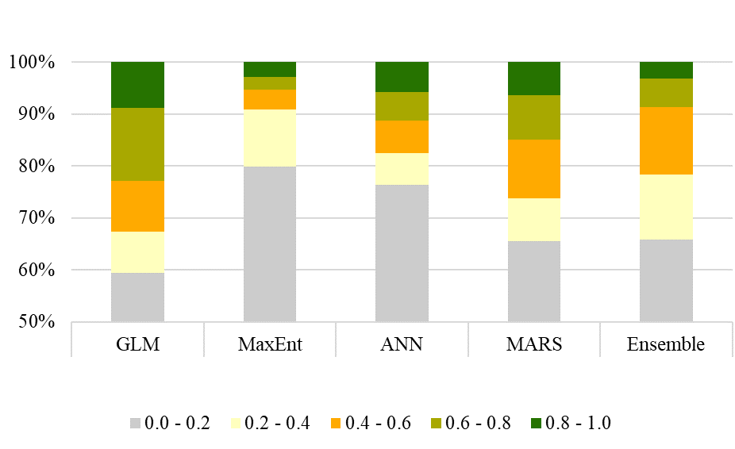 | (B)  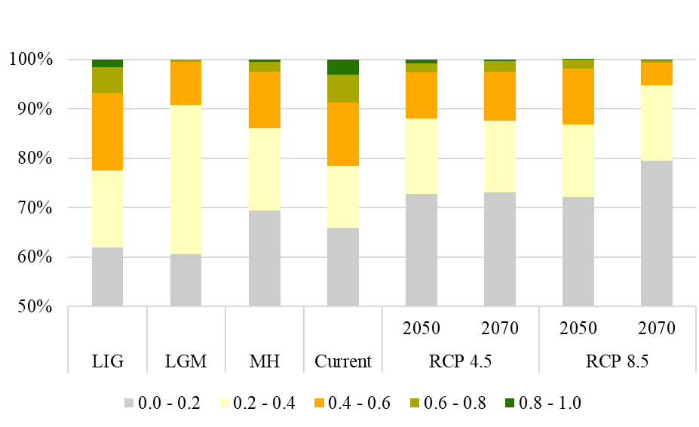
(C)  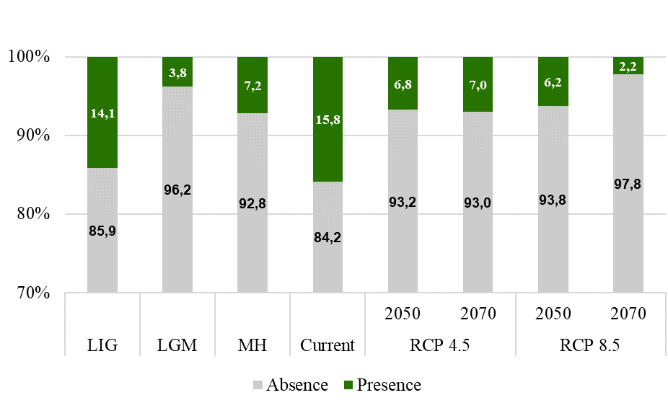 | (D)  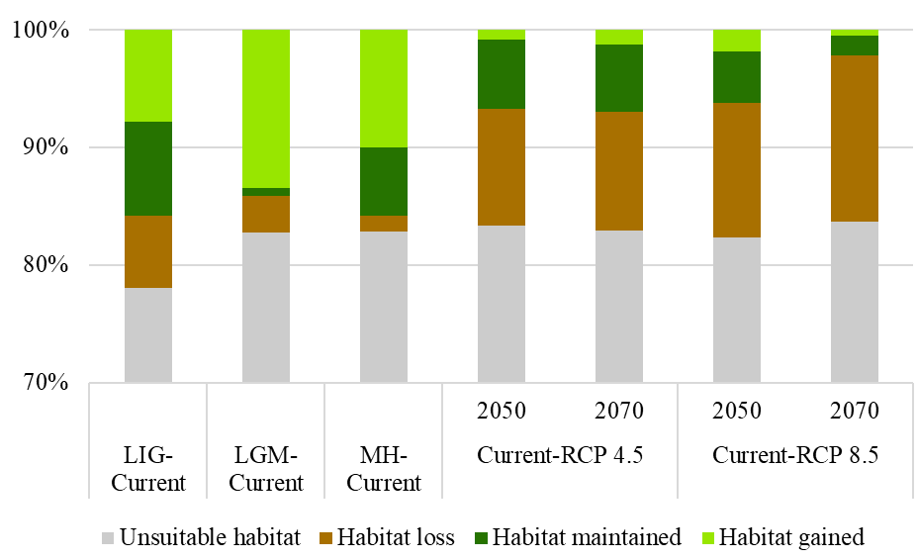
Supplementary Figure 5. Comparing models (A), habitat suitability for the different scenarios (B), absence-presence of the different scenarios in percent of area (C), evolution across scenarios compared with the present in percent of area (D).
Supplementary References
Aparicio, A., Martín-Hernanz, S., Parejo-Farnés, C., Arroyo, J., Lavergne, S., Yeşilyurt, E.B., et al. (2017). Phylogenetic reconstruction of the genus Helianthemum (Cistaceae) using plastid and nuclear DNA-sequences: Systematic and evolutionary inferences. Taxon 66(4), 868-885. doi: 10.12705/664.5.
Bechlaghem, K., Allali, H., Benmehdi, H., Aissaoui, N., and Flamini, G. (2019). Chemical Analysis of the Essential Oils of Three <i>Cistus</i> Species Growing in North-West of Algeria. Agriculturae Conspectus Scientificus 84(3), 283-293.
Cerrillo-Cuenca, E., and González-Cordero, A. (2011). "Burial prehistoric caves in the interior basin of river Tagus: the complex at Canaleja gorge (Romangordo, Caceres, Spain)," in From the Origins: The Prehistory of the Inner Tagus Region, ed. Archaeopress. BAR International Series 2219), 21-42.
Connor, S.E., Araújo, J., Boski, T., Gomes, A., Gomes, S.D., Leira, M., et al. (2021). Drought, fire and grazing precursors to large-scale pine forest decline. Diversity and Distributions 27(7), 1138-1151. doi: https://doi.org/10.1111/ddi.13261.
Cortés-Sánchez, M., Morales-Muñiz, A., Simón-Vallejo, M.D., Bergadà-Zapata, M.M., Delgado-Huertas, A., López-García, P., et al. (2008). Palaeoenvironmental and cultural dynamics of the coast of Málaga (Andalusia, Spain) during the Upper Pleistocene and early Holocene. Quaternary Science Reviews 27(23), 2176-2193. doi: https://doi.org/10.1016/j.quascirev.2008.03.010.
Dorado-Valiño, M., López-Sáez, J.A., and García-Gómez, E. (2014a). 21. Patateros, Toledo Mountains (central Spain). Grana 53(2), 171-173. doi: 10.1080/00173134.2014.903293.
Dorado-Valiño, M., López-Sáez, J.A., and García-Gómez, E. (2014b). 26. Valdeyernos, Toledo Mountains (central Spain). Grana 53(4), 315-317. doi: 10.1080/00173134.2014.936490.
Ferreira, M.R., Almeida, A.M., Quintela-Sabarís, C., Roque, N., Fernandez, P., and Ribeiro, M.M. (2021). The role of littoral cliffs in the niche delimitation on a microendemic plant facing climate change. PLoS One 16(10), e0258976. doi: 10.1371/journal.pone.0258976.
Fletcher, W.J., Boski, T., and Moura, D. (2007). Palynological evidence for environmental and climatic change in the lower Guadiana valley, Portugal, during the last 13 000 years. The Holocene 17(4), 481-494. doi: 10.1177/0959683607077027.
Franco-Múgica, F., Antón, M.G., Ruiz, J.M., Juaristi, C.M., and Ollerol, H.S. (2001). The Holocene history of Pinnus forests in the Spanish Northern Meseta. The Holocene 11(3), 343-358. doi: 10.1191/095968301669474913.
Franco-Múgica, F., García-Antón, M., Maldonado-Ruiz, J., Morla-Juaristi, C., and Sainz-Ollero, H. (2005). Ancient pine forest on inland dunes in the Spanish northern meseta. Quaternary Research 63(1), 1-14. doi: DOI: 10.1016/j.yqres.2004.08.004.
Henaoui, I.E.-A. (2013). Les Cistacées dans la région de Tlemcen (Nord-Ouest algérien) : aspects inflammabilité, combustibilité et cartographie. Université de Tlemcen.
López-Merino, L., López-Sáez, J.A., Alba-Sánchez, F., Pérez-Díaz, S., and Carrión, J.S. (2009). 2000 years of pastoralism and fire shaping high-altitude vegetation of Sierra de Gredos in central Spain. Review of Palaeobotany and Palynology 158(1), 42-51. doi: https://doi.org/10.1016/j.revpalbo.2009.07.003.
López-Merino, L., Silva Sánchez, N., Kaal, J., López-Sáez, J.A., and Martínez Cortizas, A. (2012). Post-disturbance vegetation dynamics during the Late Pleistocene and the Holocene: An example from NW Iberia. Global and Planetary Change 92-93, 58-70. doi: https://doi.org/10.1016/j.gloplacha.2012.04.003.
López-Sáez, J.A., López-Merino, L., Alba-Sánchez, F., Pérez-Díaz, S., Abel-Schaad, D., and Carrión, J.S. (2010). Late Holocene ecological history of Pinus pinaster forests in the Sierra de Gredos of central Spain. Plant Ecology 206(2), 195. doi: 10.1007/s11258-009-9634-z.
López-Sáez, J.A., López-Merino, L., Mateo, M., Serrano, O., Pérez-Díaz, S., and Serrano, L. (2009). Palaeoecological potential of the marine organic deposits of Posidonia oceanica: A case study in the NE Iberian Peninsula. Palaeogeography Palaeoclimatology Palaeoecology 271, 215-224. doi: 10.1016/j.palaeo.2008.10.020.
López-Sáez, J.A., Lopez, P., Merino, L., Cerrillo-Cuenca, E., Cordero, A., and Prada Gallardo, A. (2007). Origen Prehistórico de la Dehesa en Extremadura: una Perspectiva Paleoambiental. Revista de estudios extremeños, ISSN 0210-2854, Vol. 63, Nº 1, 2007, pags. 493-510 63.
Luelmo-Lautenschlaeger, R., López-Sáez, J.A., and Pérez-Díaz, S. (2018a). 39. Las Lanchas, Toledo Mountains (central Spain). Grana 57(3), 246-248. doi: 10.1080/00173134.2017.1366547.
Luelmo-Lautenschlaeger, R., López-Sáez, J.A., and Pérez-Díaz, S. (2018b). 40. Botija, Toledo Mountains (central Spain). Grana 57(4), 322-324. doi: 10.1080/00173134.2017.1400587.
Mateus, J.E. (1992). Holocene and present-day ecosystems of the Carvalhal Region, Southwest Portugal. PhD thesis. PhD, Universidade de Utreque.
Narbona, E., Guzmán, B., Arroyo, J., and Vargas, P. (2010). Why are fruit traits of Cistus ladanifer (Cistaceae) so variable: A multi-level study across the western Mediterranean region. Perspectives in Plant Ecology, Evolution and Systematics 12(4), 305-315. doi: 10.1016/j.ppees.2010.06.001.
Nocete, F., Queipo, G., Sáez, R., Nieto, J.M., Inácio, N., Bayona, M.R., et al. (2008). The smelting quarter of Valencina de la Concepción (Seville, Spain): the specialised copper industry in a political centre of the Guadalquivir Valley during the Third millennium BC (2750–2500 BC). Journal of Archaeological Science 35(3), 717-732. doi: https://doi.org/10.1016/j.jas.2007.05.019.
Pons, A., and Reille, M. (1988). The holocene- and upper pleistocene pollen record from Padul (Granada, Spain): A new study. Palaeogeography, Palaeoclimatology, Palaeoecology 66(3), 243-263. doi: https://doi.org/10.1016/0031-0182(88)90202-7.
Quintela-Sabarís, C., Vendramin, G.G., Castro-Fernández, D., and Isabel Fraga, M. (2011). Chloroplast DNA phylogeography of the shrub Cistus ladanifer L. (Cistaceae) in the highly diverse Western Mediterranean region. Plant Biology 13(2), 391-400. doi: 10.1111/j.1438-8677.2010.00371.x.
Robles López, S., Manzano-Rodríguez, S., Pérez-Díaz, S., and López-Sáez, J.A. (2017). 35. Labradillos mire, Gregos Range (central Spain). Grana 56(5), 398-400. doi: 10.1080/00173134.2017.1282976.
Stevenson, A.C. (2000). The Holocene forest history of the Montes Universales, Teruel, Spain. The Holocene 10(5), 603-610. doi: 10.1191/095968300670543500.
van der Knaap, W.O., and van Leeuwen, J.F.N. (1995). Holocene vegetation succession and degradation as responses to climatic change and human activity in the Serra de Estrela, Portugal. Review of Palaeobotany and Palynology 89(3-4), 153-211. doi: http://dx.doi.org/10.1016/0034-6667(95)00048-0.
van der Knaap, W.O., and van Leeuwen, J.F.N. (1997). Late Glacial and early Holocene vegetation succession, altitudinal vegetation zonation, and climatic change in the Serra da Estrela, Portugal. Review of Palaeobotany and Palynology 97(3), 239-285. doi: https://doi.org/10.1016/S0034-6667(97)00008-0.
van der Schriek, T., Passmore, D.G., Stevenson, A.C., and Rolao, J. (2007). The palaeogeography of Mesolithic settlement-subsistence and shell midden formation in the Muge valley, Lower Tagus Basin, Portugal. The Holocene 17(3), 369-385. doi: 10.1177/0959683607075839.

